|  |  |  |  |
| --- | --- | --- | --- |
|  | IT Works | Document Name |  |

# Purpose

This document provides a step-by-step guide for creating a new EC2 instance on AWS. It covers logging into the AWS Management Console, configuring settings such as AMI, instance type, network, and security, and launching and connecting to the instance.

Contents

Purpose 1

Section 1 - How to Create a New EC2 Instance 3

# 

# Section 1 - How to Create a New EC2 Instance

**This guide will walk you through creating a virtual machine (EC2 instance) on AWS step by step. Follow these instructions carefully.**

**Step 1: Log in to the AWS Management Console**

1. Open your web browser and go to the [AWS Management Console](https://aws.amazon.com/console/).
2. Enter your Username and Password, then click Sign In.

**Step 2: Open the EC2 Dashboard**

1. In the Search bar at the top of the page, type EC2.
2. Select EC2 from the dropdown menu.

**Step 3: Launch a New Instance**

1. On the EC2 Dashboard, click the Launch Instance button.

1. Enter a name for your instance, e.g., Erfys-WebServer.

**Step 4: Choose an Amazon Machine Image (AMI)**

1. Under the Amazon Machine Image (AMI) section, select Amazon Linux 2.
   * This is a free-tier eligible option.
   * It’s a lightweight and secure operating system.

**Step 5: Select an Instance Type**

1. Choose t2.micro for the instance type.
   * This is free-tier eligible and sufficient for basic tasks.

**Step 6: Configure Key Pair (Secure Login)**

1. Under Key Pair, click vockeyA screenshot of a computer

   Description automatically generated

**Step 7: Configure Network Settings**

1. Ensure the instance is in the correct VPC.
2. Enable auto-assign public IP if you want the instance accessible over the internet.
3. Security Group Settings:
   * Allow the following inbound rules:
     + SSH (Port 22): For secure login (set source to your IP).
     + HTTP (Port 80): For web traffic.

**Step 8: Launch Your Instance**

1. Review all the settings.
2. Click the Launch Instance button.

**Step 9: Check Instance Status**

1. Go back to the Instances section in the EC2 Dashboard.
2. Look for your instance and wait until its status changes to Running.

**Step 10: Connect to Your Instance**

1. Select the instance in the EC2 Dashboard.
2. Click the Connect button at the top.

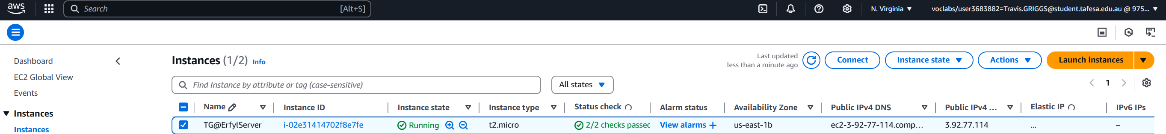

1. Choose EC2 Instance Connect for a simple browser-based terminal.
2. Click Connect to open a session.